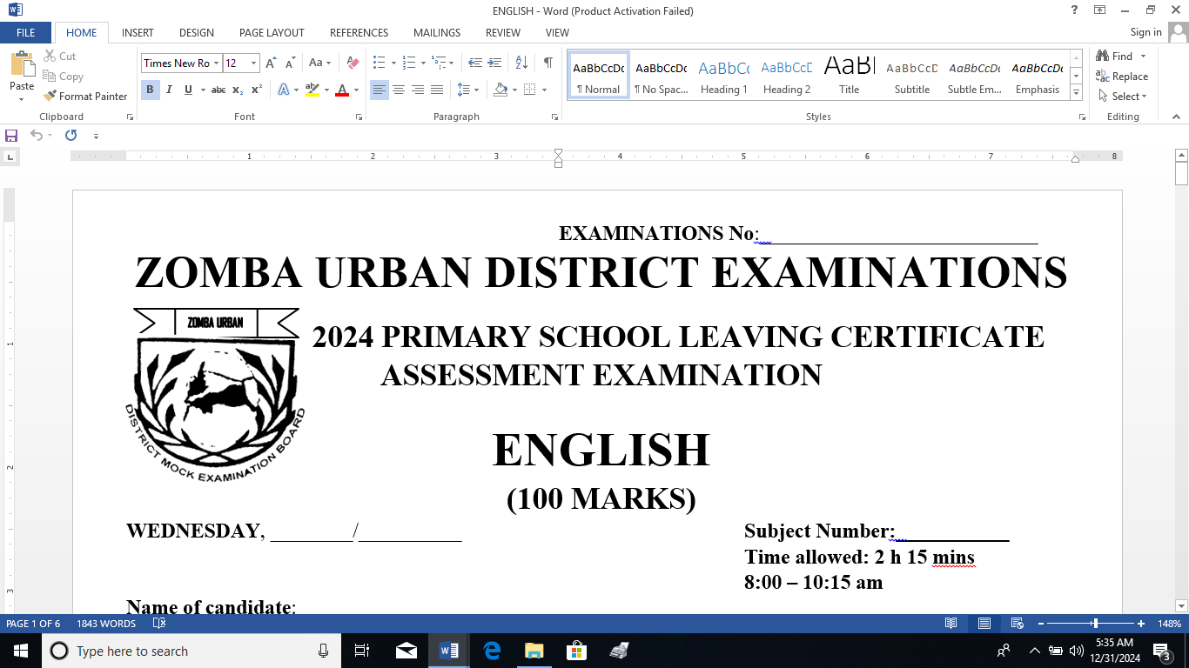**EXAMINATIONS No**:___________________________

**ZOMBA URBAN DISTRICT ASSESSMENT**

**2025 PRIMARY SCHOOL LEAVING CERTIFICATE EXAMINATION**

**MATHEMATICS**

**(100 MARKS)**

DATE : **Thursday, 30th January, 2025** **Subject Number: P134**

**Time allowed: 2 HRS**

**From :8:00 – 10:00 AM**

**Name of candidate**:_______________________________________________________________________

**(Surname First)**

**Name of School**:_________________________________________________________________________

|  |  |  |  |
| --- | --- | --- | --- |
| Question  Number | Tick if  answered | Do not write in these columns | |
| 1-30 |  |  |  |
| 31 |  |  |  |
| 32 |  |  |  |
| 33 |  |  |  |
| 34 |  |  |  |
| 35 |  |  |  |
| 36 |  |  |  |
| 37 |  |  |  |
| 38 |  |  |  |
| 39 |  |  |  |
| 40 |  |  |  |
| 41 |  |  |  |
| 42 |  |  |  |
| 43 |  |  |  |
| 44 |  |  |  |
| 45 |  |  |  |
| **TOTAL** | |  |  |

**Instructions**

1. This paper contains 7 printed pages please check
2. There are two sections in this paper, A and B
3. Answer all questions in section A and B
4. The maximum number of the marks for each answer is indicated against each question
5. In section A Encircle the letter representing the right answer to each question. Write your answers to the questions in section **B** in the spaces provided on the question paper.
6. In the table provided on this page **, tick** against the question number you have answered apart from questions **1 – 30.**
7. **IMPORTANT**

* Write your **name** and **name of your school** in the spaces provided above and your **Examination Number** on top of each

page of the question paper.

* Hand in your worked question paper to the invigilator when time is called to stop writing. **Turn Over**

**SECTION A (40MARKS)**

1. What is CDXL in Hindu Arabic numeral
2. 440 C. 660
3. 640 D. 460
4. What is the simplest form of the following ration
5. 1 : 8 C. 1 : 2
6. 1 : 4 D. 2 : 1
7. What is 25678 to the nearest thousand
8. 25 000 C. 27 000
9. 26 000 D. 30 000
10. A quadrilateral has one pair of opposite sides parallel. What is the name of this quadrilateral
11. Rhombus C. Parallelogram
12. Trapezium D. Kite
13. A vegetable garden is 57m long and 36m wide. What is the length of the wire required to fence the garden
14. 21m C. 186m
15. 93m D. 2052m
16. Chifundo measured an angle and found that it was 1250. What type of an angle is it?
17. Reflex C. Obtuse
18. Acute D. Right angle
19. A person celebrated his diamond jubilee ten years ago. How old is he now?
20. 40 C. 60
21. 50 D. 70
22. Which in equality symbol should be written instead of a box to come up with correct inequality

x - 7 x - 3

1. < C. ≤
2. > D. ≥
3. A textile factory paid 48 000 as a custom duty for a machine worth K240 000. At what rate was custom duty charged.
4. 5 % C. 15%
5. 10% D. 20%
6. Mwayi was offered a discount of 8% on shoes marked K4500. How much did she pay for the shoes
7. K360 C. K4472
8. K4140 D. K4860
9. What is the simplified form of 4m – b + m + 7b
10. 3m + 8b C. 5m + 6b
11. 4m – 8b D. 5m – 6b
12. What is the value of n in the equation 4 + 5n = 24
13. 2 C. 4
14. 3 D. 6
15. The height of a drawing of a building is 3cm. If a scale of 1cm to represent 300cm was used, what is the height of the building
16. 100cm C. 303cm
17. 297cm D. 900cm
18. What is the missing number in the following number pattern (100, 2) (5, 40) (200, 1) (50, ___)
19. 1 C. 4
20. 2 D. 6
21. A man bought goods for K40 000 and sold them for K60 000. What is the profit percent
22. 20% C. 50%
23. 33% D. 57%
24. Takondwa and Sandra shared sweets in the ration 5: 7. If Sandra got 42 sweets, how many sweets did Takondwa get?
25. 72 C. 30
26. 52 D. 12
27. Yankho takes 2 hours 30 minutes to walk a distance of 15km. Calculate Yankho’s speed in metres per minute
28. 6m/min C. 100m/min
29. 10m/min D. 125m/min

Table 1 shows property and its insurance premium paid per month. Use it to answer question 18

Table 1

|  |  |
| --- | --- |
| **Property** | **Insuranace premium per month** |
| House | K900 |
| Bicycle | K750 |
| Motor vehicle | K450 |
| House furniture | K375 |

1. If a person paid a total insurance premium of K45 000 for an agreed period of 5 years for ensuring one of the property in Table 1. Which property was ensured
2. Bicycle C. House furniture
3. House D. Motor vehicle
4. Calculate the total cost of the following items

10 tomatoes at 2 for K50

3 books for K500

1. K550 C. K1600
2. K750 D. K1 750
3. Table 2 shows official exchange rates of the Malawi kwacha against some foreign currencies

|  |  |  |
| --- | --- | --- |
| Currency | Buying | Selling |
| Us Dollar($) | 557 | 571 |
| British pound (£) | 859 | 880 |

If a p$erson exchanged $ 20 and £ 10, how he get altogether?

1. K8, 590 C. K19, 730
2. K 11, 140 D. K20,220

**SECTION B**

1. (a) Find the difference between 3 1/3 and the product of 2 2/3 and ¼ (4marks)

(b) Malume has lemons and Mafunde has m lemons. If the sum of Malume’s and Mafunde’s

lemons is less or equal to 30, formulate an inequality and solve it to find the value of m. (5marks)

1. (a) Multiply the difference between 701.2 and 681 by 2.3, give the answer to1 decimal place (3marks)

(b) Bengo had 4x kwacha. He gave x kwacha to his friend. If he remained with K21000, calculate the amount of money that Bengo gave to his friend (4marks)

1. Calculate the compound interest on K45 000 for 2 years at 20% per annum (7marks)
2. (a) Given that the average of 6, 10, 8 and y is 9, find the value of y? (5marks)

(b) If a motorbike is sold for K1800 000, a loss of 25% is made . calculate the price at which the motorbike would have been sold to make a profit of 10%. (5marks)

Figure 1 shows a triangle ABC inside a circle of diameter 28cm

A

B C

28cm

1. Find the area of the shaded part (5marks)
2. (a) Tadala scored 75% of the total number of marks of a test. If the total number of marks of the test was 40. Calculate the marks that Tadala scored (3marks)

(b) James, Zione and Mphatso shared a certain amount of money in the ratio 1: 2: 3 respectively, If James received K300 and Zione K600. Find the total money shared (4marks)

1. a). A lawn is in form of a triangle XYZ in which Yz = 9cm, XY = 8cm and angle XYZ = 1300. Using a ruler and a protractor only, draw the triangle . measure and state the length of XZ (5marks)

b). measure and state the length of XZ (1 Mark)

1. The bar graph below shows the PSLE examination results at a certain school for 5 years in Zomba Urban. Use it to answer questions 28a, 28b and 28c.

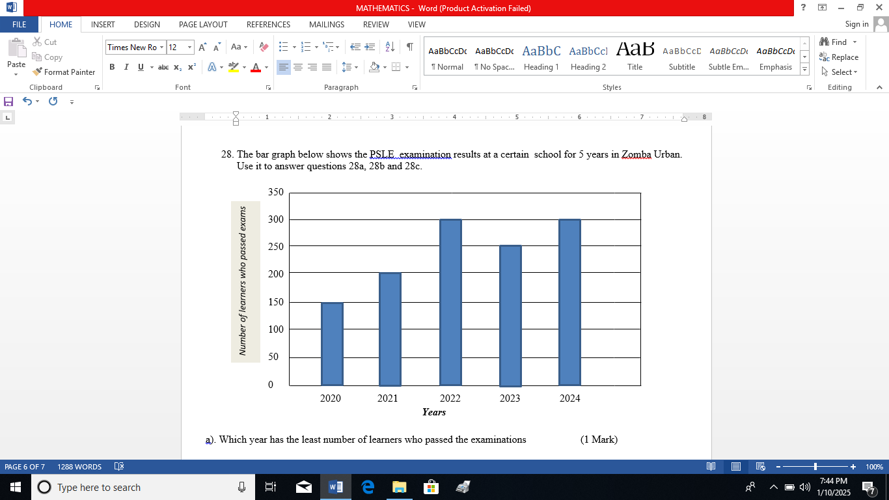

a). Which year has the least number of learners who passed the examinations (1 Mark)

b.) In the past 5 years what was the average number of learners who passed the examinations at this school

(3 Marks)

What is the difference between the number of learners who passed examination in 2023 and 2020 (1 Mark)

1. The table shows income tax rates

|  |  |
| --- | --- |
| **Income per month** | **Rate of tax** |
| First K9000 | 0% |
| Next K3000 | 15% |
| Excess (over) K12000 | 30% |

Mrs Moyo earns a salary of K39400 a month. Find the amount he gets after deducting tax (5marks)

**END OF QUESTIONS**